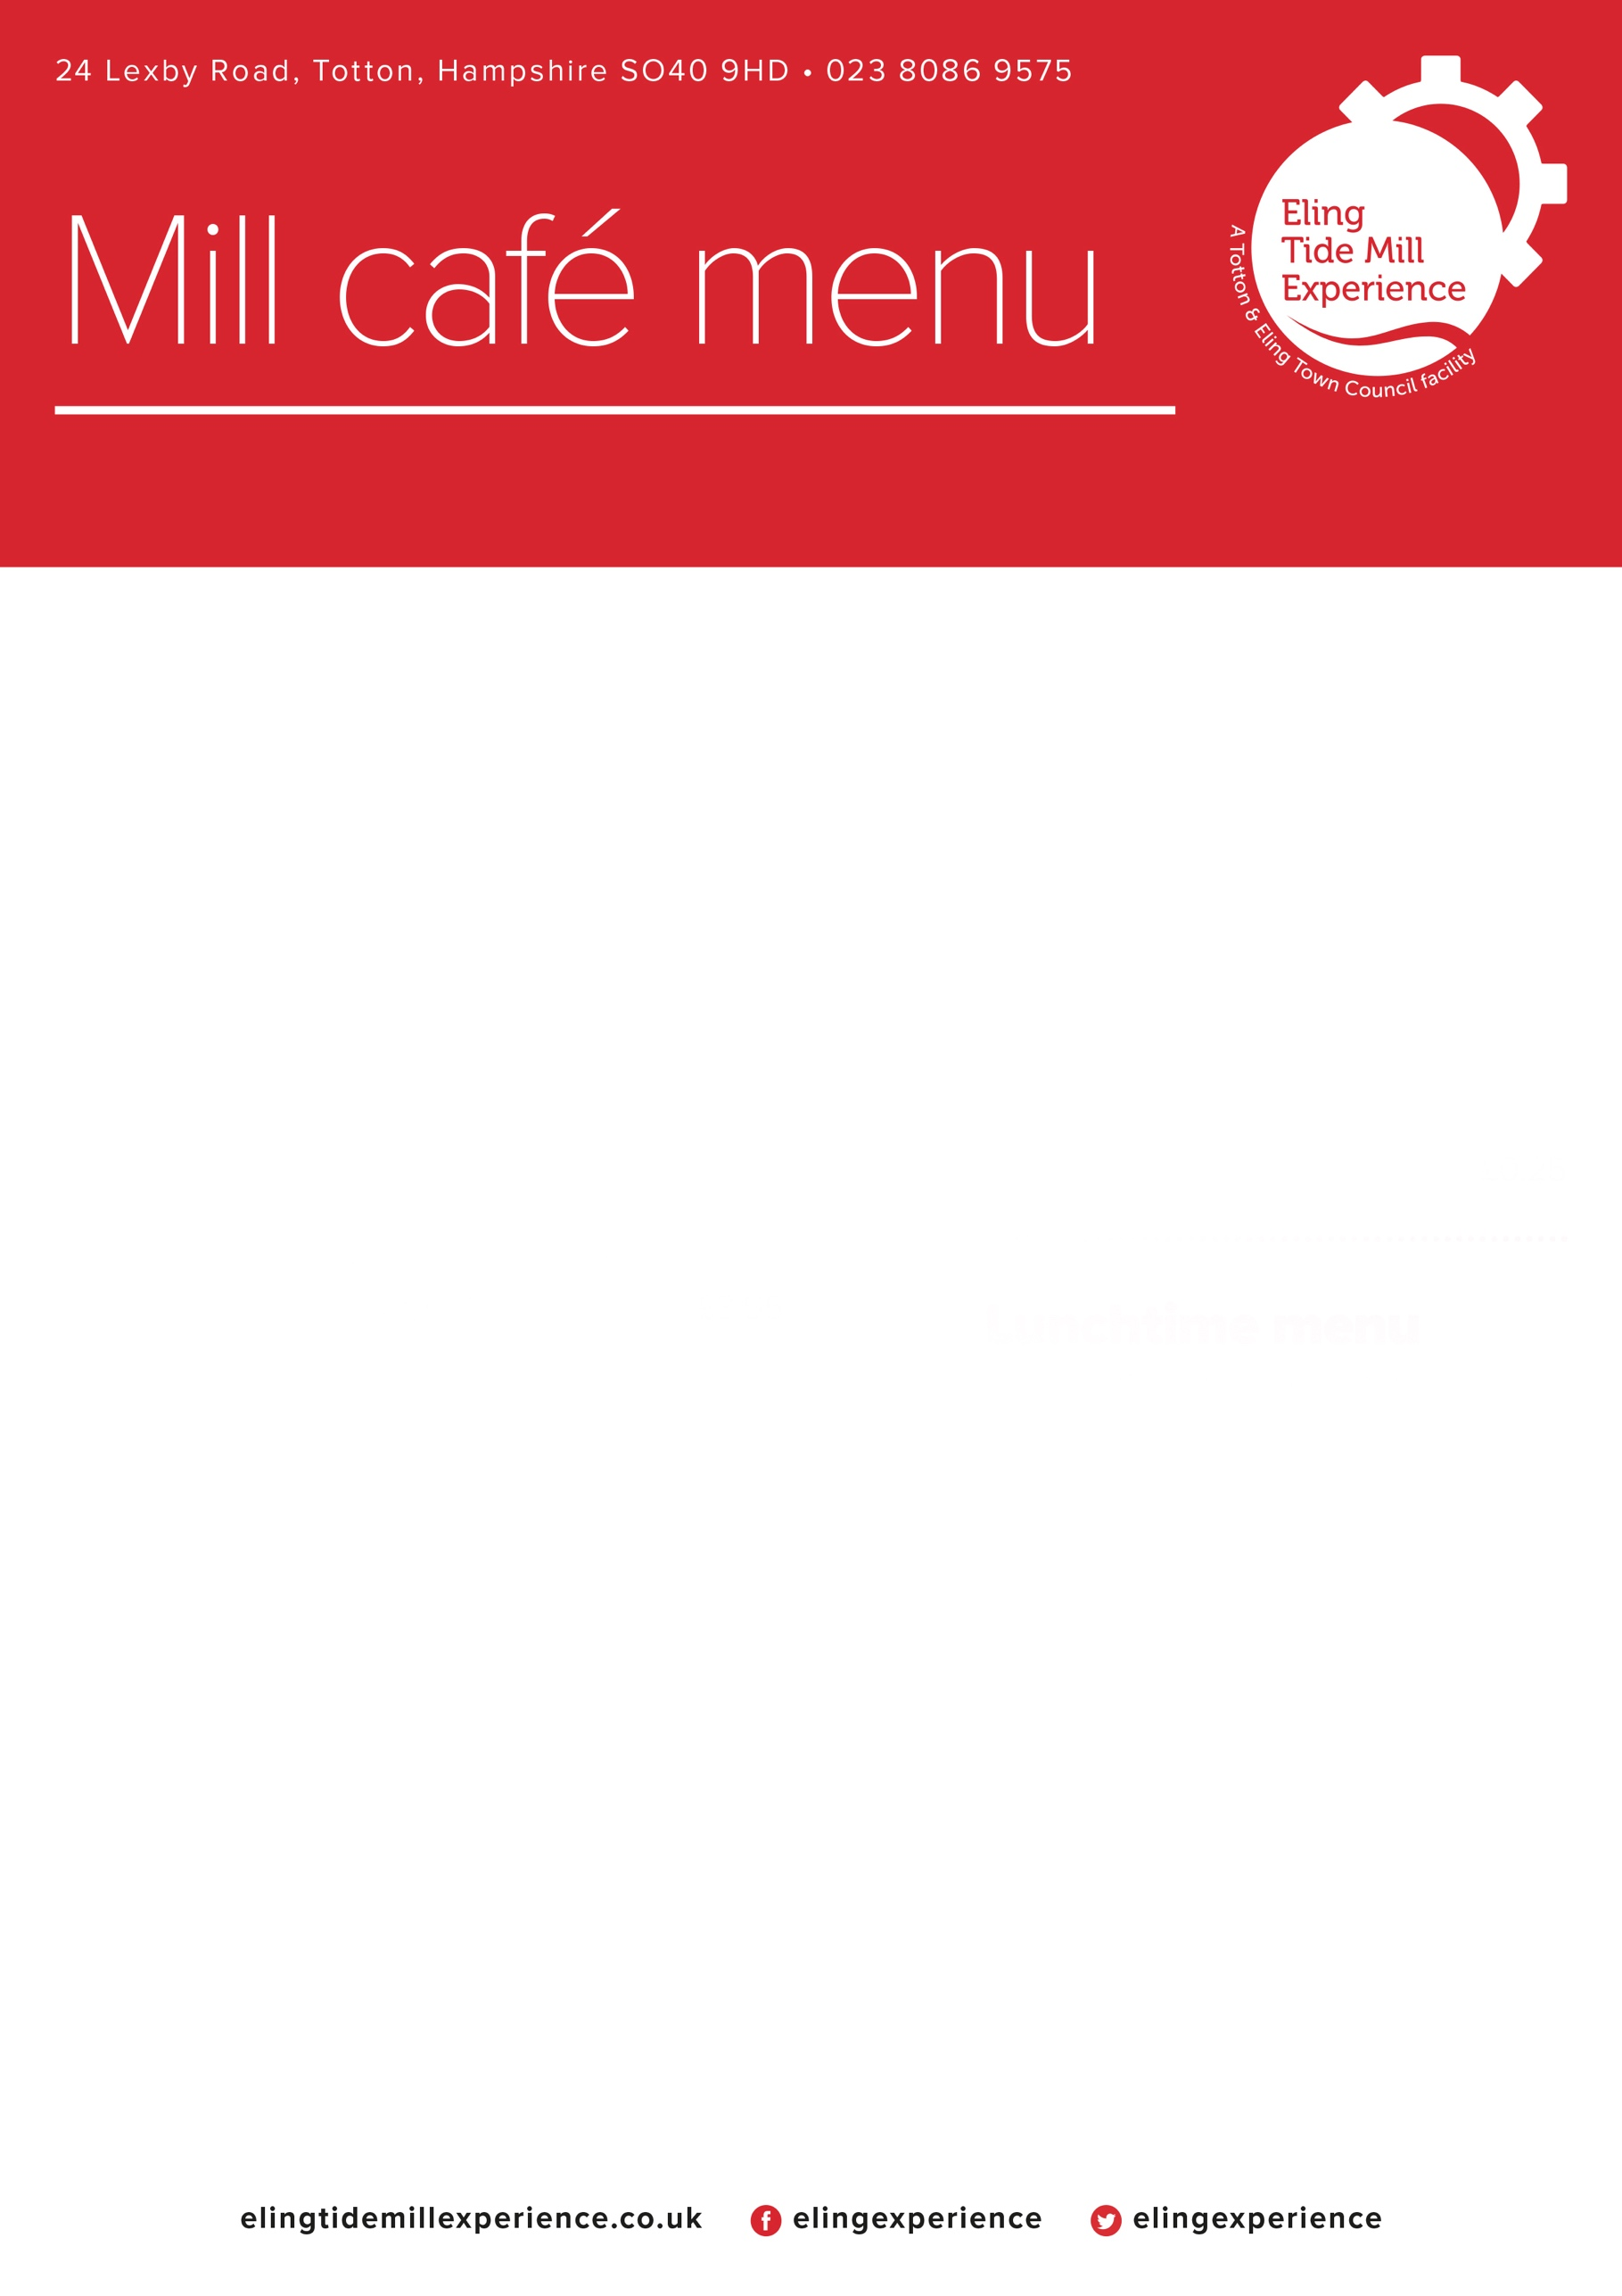

**See our board for daily specials**

**Sweet bites**

Selection of slices/ cakes £3.50

Cream tea for one £5.50

(scone with jam, cream and a drink)

Scone with butter £3.25

Toasted teacake £2.25

Biscuits crisps and snacks from £1.00

Ice cream £2.50

Ice lollies £2.00

Doggy ice cream £3.25

**Drinks**

Coffees £3.50

Mocha £4.00

Tea £2.50

Specialty Tea £2.75

Hot chocolate £3.50

Iced coffee £3.50

Babychino £1.00

Can, Fruitshoot, Oasis, Juice cartons £1.50

Fentimens Curiosity Cola £3.00

Water £1.50

Glass of milk £1.50

Coffee syrups and milk alternatives £0.50

Disposable cup charge £0.25

Childrens menu on reverse

**Sandwiches or Baguettes/Panini**

**HOT BITES**

Sandwich. Baguettes/panini

Bacon Brie and Cranberry £6.95 £7.45

Bacon £4.95 £5.45

Sausage £4.95 £5.45

Vegetarian sausage £4.95 £5.45

Tuna Melt £5.95 £6.45

Cheese on Toast £5.50

Beans on Toast £5.50

Cheese bean on Toast £6.50

Pastries Meat £4.00

Pastries Vegetarian £3.50

Chips/wedges £2.50

**LIGHT BITES**

Ham £4.95 £5.45

Cheese £4.95 £5.45

Ham & Cheese £5.95 £6.45

Tuna mayonnaise £4.95 £5.45

Egg mayonnaise £4.95 £5.45

Coronation Chicken £5.95 £6.45

Chicken & Bacon £5.95 £6.45

Coleslaw £0.50

Add: Cucumber-Tomato-Lettuce-Onion £0.50

Light bites served with crisps

Plain Jacket £5.50

Jacket +1 Filling £6.50

Extra fillings £0.50

Fillings as above

Soup of the day £5.50